Test 1: num_plants = 167 target_size = (299,299) batch*size = 32 epochs = 100 Model: "sequential" __* Layer (type) Output Shape Param #  
================================================================= inception_resnet*v2 (Model) (None, None, None, 1536) 54336736  
__* global_average*pooling2d (Gl (None, 1536) 0  
__* dense (Dense) (None, 2048) 3147776  
_ dense*1 (Dense) (None, 1024) 2098176  
__* dense_2 (Dense) (None, 167) 171175  
================================================================= Total params: 59,753,863 Trainable params: 59,693,319 Non-trainable params: 60,544 72/72 [==============================] - 106s 1s/step - loss: 1.4163 - accuracy: 0.6393 test acc: 0.63932294

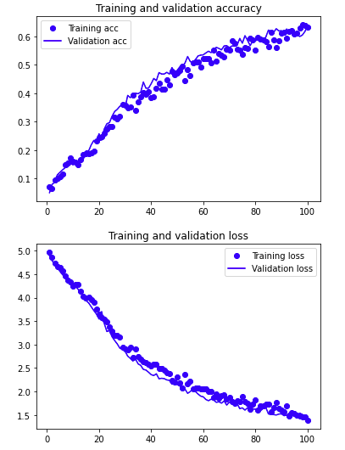

Conclusion: Representation space was too small in the dense layers. Going to test a larger represenation dense layer.